**EXPERIMENT–3**

**Objective:** To create sequence diagram for

1. Railway Management System
2. Library Management System
3. Hospital Management System

**Hardware/Software Requirements:** Star UML

**Theory:** Sequence diagrams describe interactions among classes in terms of an exchange of messages over time. A sequence diagram is a good way to visualize and validate various runtime scenarios. These can help to predict how a system will behave and to discover responsibilities a class may need to have in the process of modeling a new system. It describes how—and in what order—a group of objects works together. These diagrams are used by software developers and business professionals to understand requirements for a new system or to document an existing process. Sequence diagrams are sometimes known as event diagrams or event scenarios.

1. **Railway Management System**

**Diagram:**

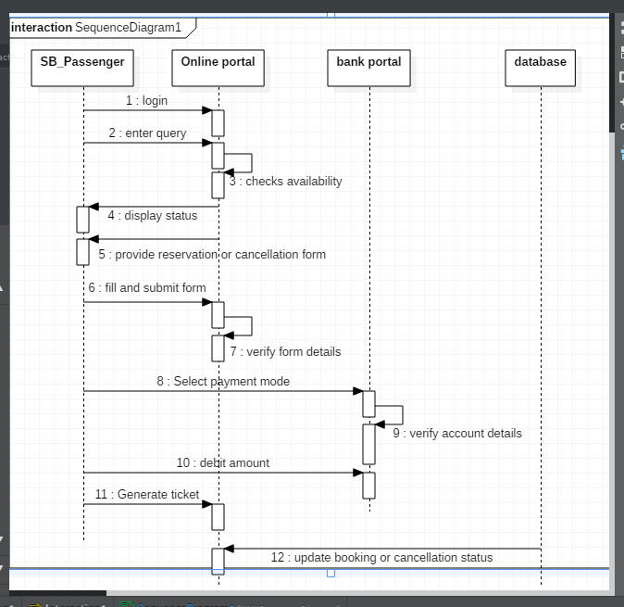

**Description:**

1. **Passenger and Online Portal**

**Functions**

1. Passenger logins into the online portal.
2. Passenger enter query into the online portal.
3. Online portal checks availability of seats and train status.
4. Online portal displays status of the trains to the passenger.
5. Online portal provides either reservation or cancellation form to the passenger.
6. Passenger fills and submits the form to the online portal.
7. Online portal verifies the details filled by the passenger.
8. Online portal generates the desired ticket for the passenger.
9. **Passenger and Bank Portal**

**Functions**

1. Passenger selects the payment mode for making payment for the ticket.
2. Bank portal verifies the details entered by the passenger for payment.
3. The amount is debited from the passenger’s account by the bank portal.
4. **Online Portal and Database**

**Functions**

1. The online portal updates the status and availability of the trains, after a passenger books a ticket, in the database.
2. **Library Management System**

**Diagram:**

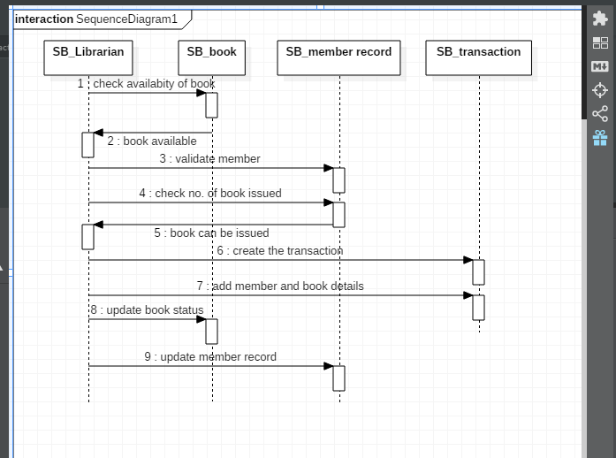

**Description:**

1. **Librarian and Book**

**Functions**

1. Librarian checks the availability of the book into library.
2. If book is available in the library it will known to librarian.
3. Librarian will calculate the fine amount of the book.
4. Librarian will update the status of book like availability or not.
5. **Librarian and Member Record**

**Functions**

1. Librarian will verify the member record whether it is good or bad.
2. Members record will provide the availability of book to Librarian or how many book is issued by the member.
3. Librarian will update the member record like issuing, fine , bill ,etc.
4. **Librarian and Bill**

**Functions**

1. Librarian will generate the bill of book issued by the member.
2. Member will pay fine of book to the Librarian.

1. **Book and Member Record**

**Functions**

1. It simply tell that how many book is issued by member.
2. **Hospital Management System**

**Diagram:**

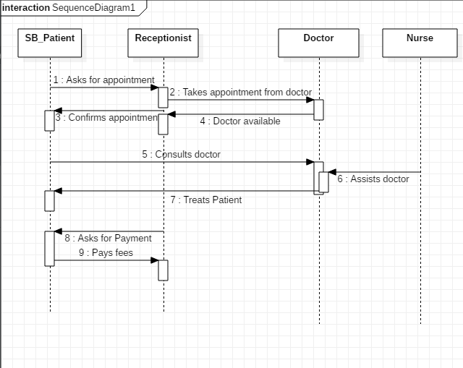

**Description:**

1. **Patient and Receptionist**

**Functions**

1. Patient asks for the appointment of doctor from the reception.
2. Receptionist confirms the appointment from the doctor to the patient.
3. Receptionist asks for the payment from the patient.
4. Patient pays the consultation fee at the reception to the receptionist.
5. **Receptionist and Doctor**

**Functions**

1. Receptionist takes appointment on behalf of the patient from the doctor.
2. Receptionist checks if the doctor is available.
3. Doctor checks for the free slots and timings when he is available.
4. Receptionist will fix the patient’s appointment.
5. **Patient and Doctor**

**Functions**

1. Patient consults the doctor for checkup and medication.
2. Doctor treats the patient and provides the medical aid and services.
3. **Doctor and Nurse**

**Functions**

1. Nurse assists the doctors in providing proper health care medication to patient.
2. Doctor needs a nurse in Operation Theater to assist him while a surgery is performed.